**ISEM 3006 Data Management in Business**

**Exercise 4**

**SQL SELECT**

**Use the Trustful Property Rental Company Database in Exerice 3.**

**Use PostgreSQL Select statement to answer the following queries.**

**Unless state otherwise, the case of strings is important, i.e. if I ask you to retrieve properties that are located in 'KLN', you only retrieve properties that are located in 'KLN', but not 'kln', 'Kln', 'kLn', etc.**

**The ordering of the rows is not important, unless I ask you to sort the output**

1. Similare to Q12 in Exercise 3, for each client, list out the client number, client name, and the number of properties that he/she has viewed. (Note that a client may view a property more than 1 times.)

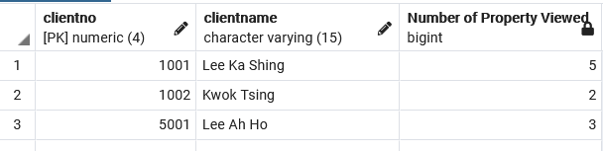

SELECT V.ClientNo, C.ClientName ,

COUNT( DISTINCT V.PropertyNo) AS “Number of property viewed”

FROM Viewing V [INNER] JOIN Client C

GROUP BY ClientNo ;

1. List the owner number and name of the property owners whose properties have been viewed in June 2020. Order the output by owner’s name and remove any duplication.

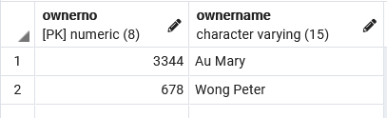

SELECT P.OwnerNo, PO.OwnerName

FROM Property P

[INNER] JOIN Viewing V ON P.PropertyNo = V.PropertyNo

[INNER] JOIN PropertyOwner PO ON P.OwnerNo = PO.OwnerNo

WHERE V.ViewDateTime BETWEEN '2020-06-01 00:00:01' AND '2013-06-30 23:59:59';

1. List the owner number and name of the property owners who have listed properties which is taking care of by employee belongs to a branch loacated at the city ‘NT’ and the employee has been hired by the company more than 365 days (when the query is executed).

SELECT PO.OwnerNo, PO.OwnerName

FROM PropertyOwner PO

[INNER] JOIN Property P ON PO.OwnerNo = P.OwnerNo

[INNER] JOIN Employee E ON E.EmployeeID = P.EmployeeID

WHERE

E.BranchCode IS IN( SELECT BranchCode FROM Branch WHERE BranchCity = ‘NT’)

AND

CURRENT_DATE - DateHired > 365 ;